City Council – Action Request Form

Date: | January 21, 2025
To: | Mayor, Mayor Pro Tempore, and Members of the City Council
From: | Chris Murphy, Director of Planning and Development Services  Camille French, City Attorney
Council Action Requested:

Resolution Authorizing the City Manager to Enter into a First Amended and Restated Interlocal Agreement with the Town of Lewisville for Zoning Enforcement and Administrative Services Assistance
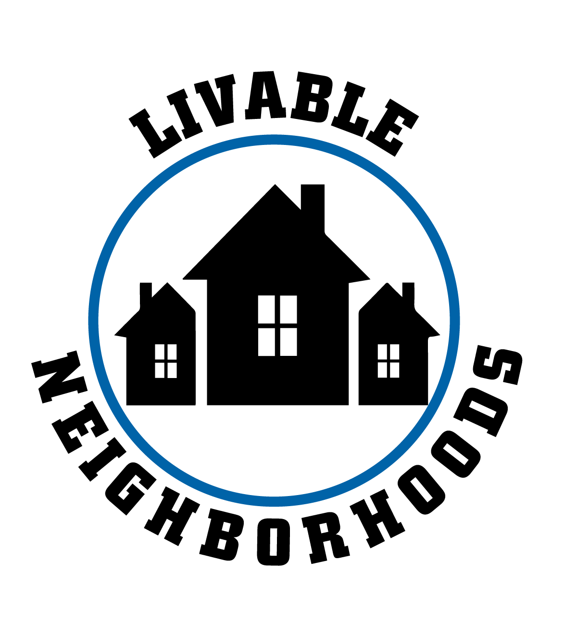
Strategic Focus Area: Livable Neighborhoods
Strategic Objective: Interlocal Agreement with the Town of Lewisville
Strategic Plan Action Item: No
Key Work Item: No
Summary of Information:

The Planning and Development Services Department has been providing zoning enforcement and administrative services assistance to the Town of Lewisville (the “Town”) pursuant to an agreement entered into on October 27, 2008. The City is willing to continue providing said services to the Town pursuant to amended terms which will be memorialized in an amended and restated interlocal agreement. The amended and restated agreement does two things:

- It eliminates City responsibility for administration of the Town Zoning Board of Adjustment from the City including, but not limited to, taking applications for meetings, preparing advertisements and agendas for meetings, providing staff for meetings, and training board members.

- It eliminates City responsibility for providing staff to attend Town Planning Board meetings and Town Council meetings.

Committee Action:

Committee |  | Committee of the Whole  1/21/2025 | Action | Approval
For |  | Unanimous | Against
Remarks:

