Information Item

Date: | January 13, 2025
To: | Mayor, Mayor Pro Tempore, and Members of the City Council
From: | Dr. Shaleen Miller, Director of Sustainability & Intergovernmental Relations  Moriah Gendy, Food Resilience Program Manager  Sharon Wojda, Assistant City Manager
Subject: Food Resilience Planning Report

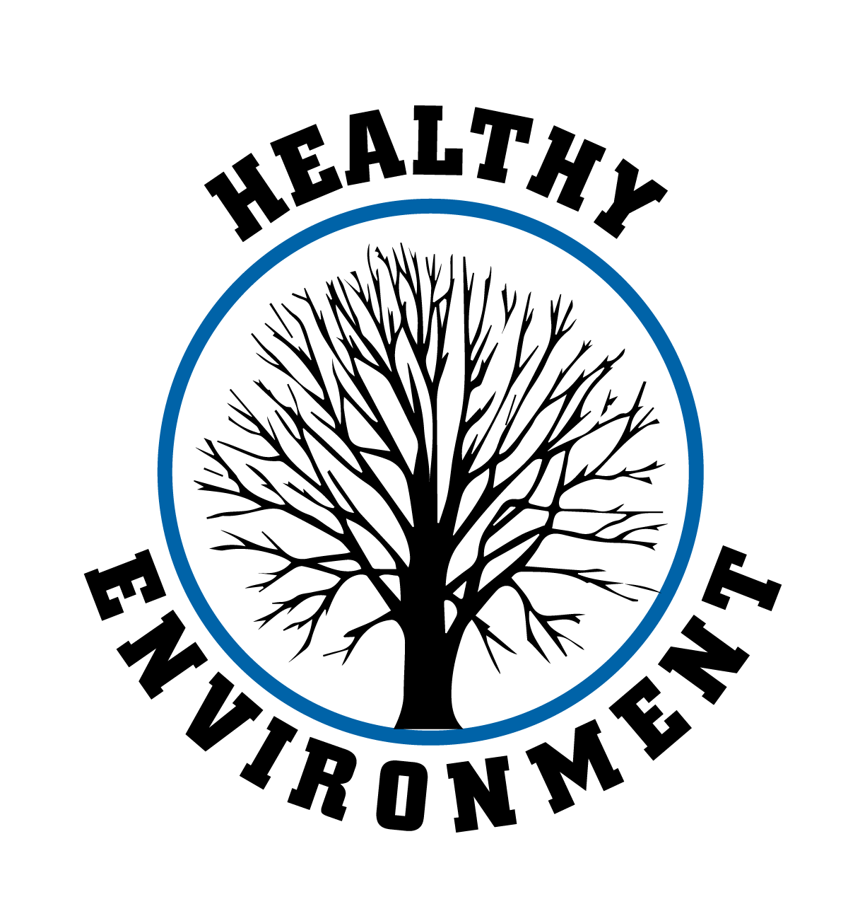
Strategic Focus Area: Healthy Environment
Strategic Objective: N/A
Strategic Plan Action Item: N/A
Key Work Item: N/A
The Food Resilience Report is being presented to the City Council as an informational item to highlight the City of Winston-Salem’s ongoing commitment to strengthening the local food system. Food Resilience, defined as the ability of a food system to consistently provide sufficient, nutritious, and accessible food despite challenges, has been a continuing focus for the City. This report marks the crossroads of what this work should look like for the City and for the broader community. It aims to define future directions for addressing food insecurity and building a more resilient food system that meets community needs.

The assessment was launched in January 2024 by the City’s Department of Sustainability and engaged a wide range of stakeholders, including residents, community organizations, and larger institutions. Through surveys, public meetings, interviews, and benchmarking, the assessment identified significant vulnerabilities in the local food system. Key findings include that 55,630 local residents experience food insecurity, with many unable to access assistance programs. Challenges such as limited grocery access in underserved areas, inadequate transportation, and climate-related risks further exacerbate the issue. Based on these insights, the assessment outlines strategic priorities and recognizes some ways that the city could proceed with support in this area.

This report does not provide a detailed roadmap but rather serves as a starting point to inspire collective action. It recognizes that many of the necessary interventions require collaboration with partners such as the County Health Department, local health providers, and community organizations. By presenting this report to the Council, the City seeks to share its findings, highlight the scope of its role, and foster partnerships to address the systemic challenges of food insecurity and resilience.

December 16, 2024, Urban Food Policy Council approved a letter supporting the Report. In addition, partner and contributor, Rachel Zimmer, from WakeForest School of Medicine has provided a Letter of Support.

