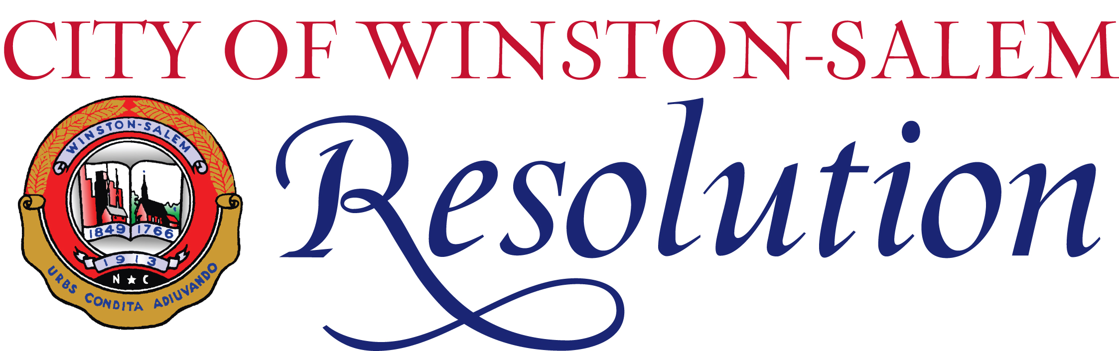

HONORING 2025
DR. MARTIN LUTHER KING, JR.
YOUNG DREAMERS’ AWARD RECIPIENTS
ANGELICA REGALADO CIEZA AND
JAMES SINGLETARY

WHEREAS, the Dr. Martin Luther King, Jr. Young Dreamers’ Award was established by the Winston-Salem Human Relations Commission in 2009; and

WHEREAS, the purpose of the Dr. Martin Luther King, Jr. Young Dreamers’ Award is to recognize two outstanding emerging or proven young adult leaders who reside in the City of Winston-Salem and have produced a meaningful result in community inclusiveness and race relations; and

WHEREAS, the goal of the Dr. Martin Luther King, Jr. Young Dreamers’ Award is to encourage young adults to participate in philanthropic, altruistic community involvement reflecting the spirit in which Dr. Martin Luther King, Jr. lived and encouraged others to live; and

WHEREAS, the Dr. Martin Luther King, Jr. Young Dreamers’ must be 18-40 years of age on or before January 17, 2025; and

WHEREAS, the Dr. Martin Luther King, Jr. Young Dreamers’ are residents of Winston-Salem who have demonstrated outstanding work and dedication in the Winston-Salem community and can neither hold an executive leadership position within his/her organization, nor be an elected government official; and

WHEREAS, the Dr. Martin Luther King, Jr. Young Dreamers’ have made a tangible difference in the lives of others who may have otherwise been overlooked, ignored, or disadvantaged. Specific examples include fostering positive race relations, vocalizing or acting against an injustice, leading inclusiveness among all individuals, embracing those who are perceived as being different, and celebrating religious diversity. The Young Dreamers’ civic and/or community-oriented work has resulted in tangible results benefiting disenfranchised persons in the community.

NOW, THEREFORE, BE IT RESOLVED, that Angelica Regalado Cieza and James Singletary are recognized and honored as the 2025 Dr. Martin Luther King, Jr. Young Dreamers in the City of Winston-Salem.

Dated this 21st Day of January, 2025

