City Council – Action Request Form

Date: | January 21, 2025
To: | Mayor, Mayor Pro Tempore, and Members of the City Council
From: | Angel Wright-Lanier, Assistant City Manager  Shantell McClam, Neighborhood Services Director
Council Action Requested:
Resolution extending the time for Wynnefield Properties, Inc. to close on the purchase of real property from the City for the purpose of developing The Lofts at Motor Road to provide affordable housing
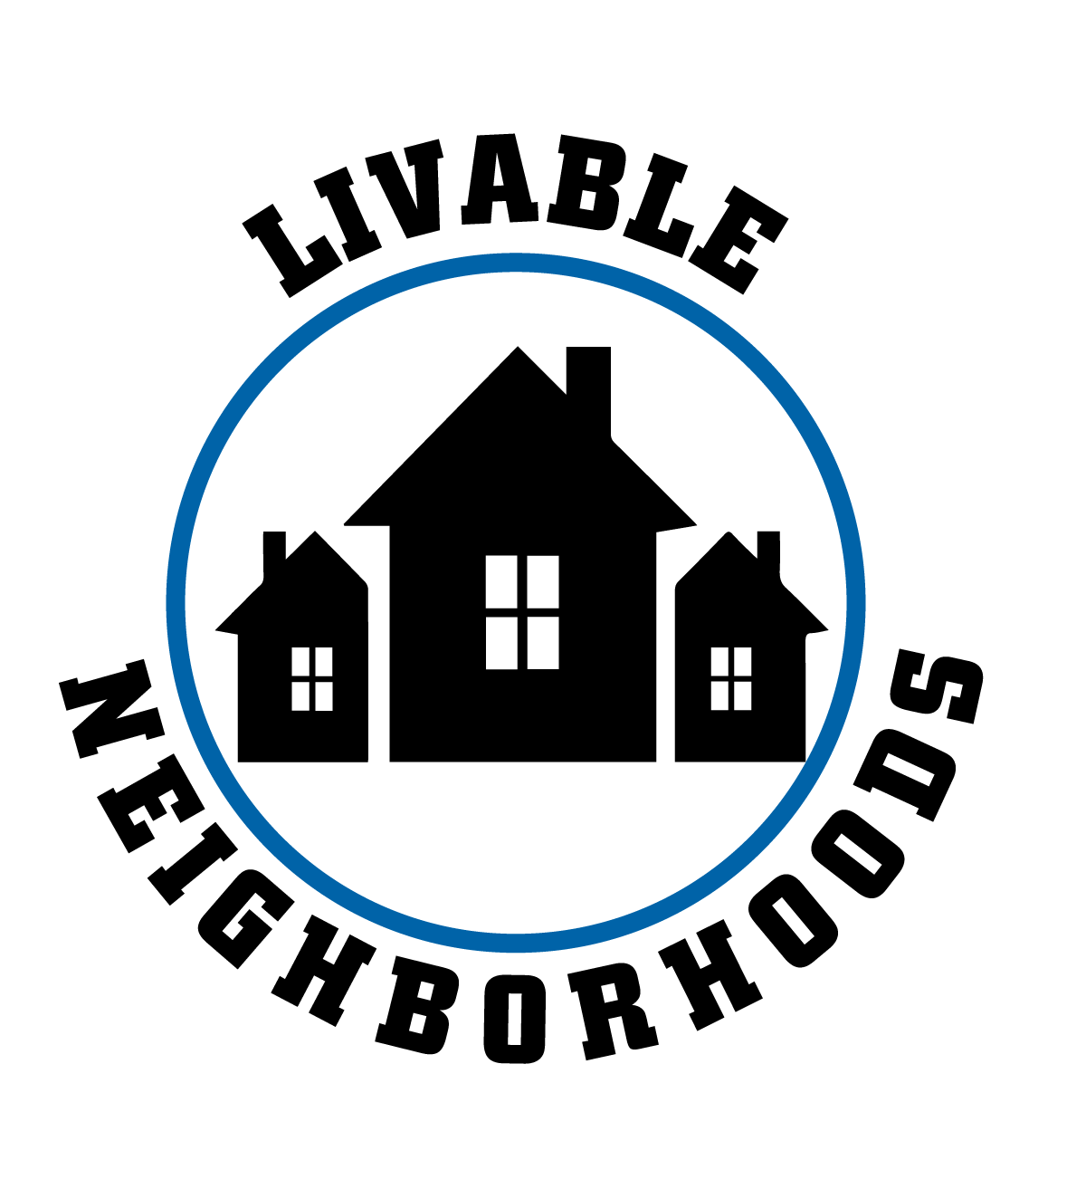
Strategic Focus Area: Livable Neighborhoods
Strategic Objective:
Strategic Plan Action Item:
Key Work Item:
Summary of Information:
On September 18, 2023, the Mayor and City Council passed a Resolution authorizing the sale of approximately 18.5 acres of vacant City-owned land near the intersection of Motor Road and Old Walkertown Road for $1.00 to a developer, Wynnefield Properties, Inc., or its successor(s) and/or assign(s). Said Resolution required that the closing occur on or before December 31, 2024. The City also agreed to loan $6,579,540 in ARPA revenue replacement funds to help in the construction of the project.

The developer was awarded Low Income Housing Tax Credits from the North Carolina Housing Finance Agency for development of the affordable rental project known as The Lofts at Motor Road. As a result, the developer does not anticipate being able to close on the purchase and construction financing until at least the second quarter of 2025. The deadline for the closing to occur therefore needs to be extended until December 31, 2025.

This extension will not alter or otherwise change any of the other terms in the September 18, 2023 resolution, including, but not limited to, the City’s commitment to loan the developer $6,579,540 from ARPA revenue replacement funds as gap financing for this project.
Staff is supportive of this request.
Committee Action:
Committee of the Whole
Committee |  | 1/21/2025 | Action | Approval
For |  | Unanimous | Against
Remarks:

