City Council – Action Request Form

Date: | January 21, 2025
To: | Mayor, Mayor Pro Tempore, and Members of the City Council
From: | Jeff Fansler, Director of Transportation  Aaron King, Assistant City Manager
Council Action Requested:
Resolution Authorizing a Letter of Support for the City of Winston-Salem and Winston-Salem Transit Authority’s Application for the FY25 Bus and Bus Facilities Competitive Program and Low or No Emission Grant Program.

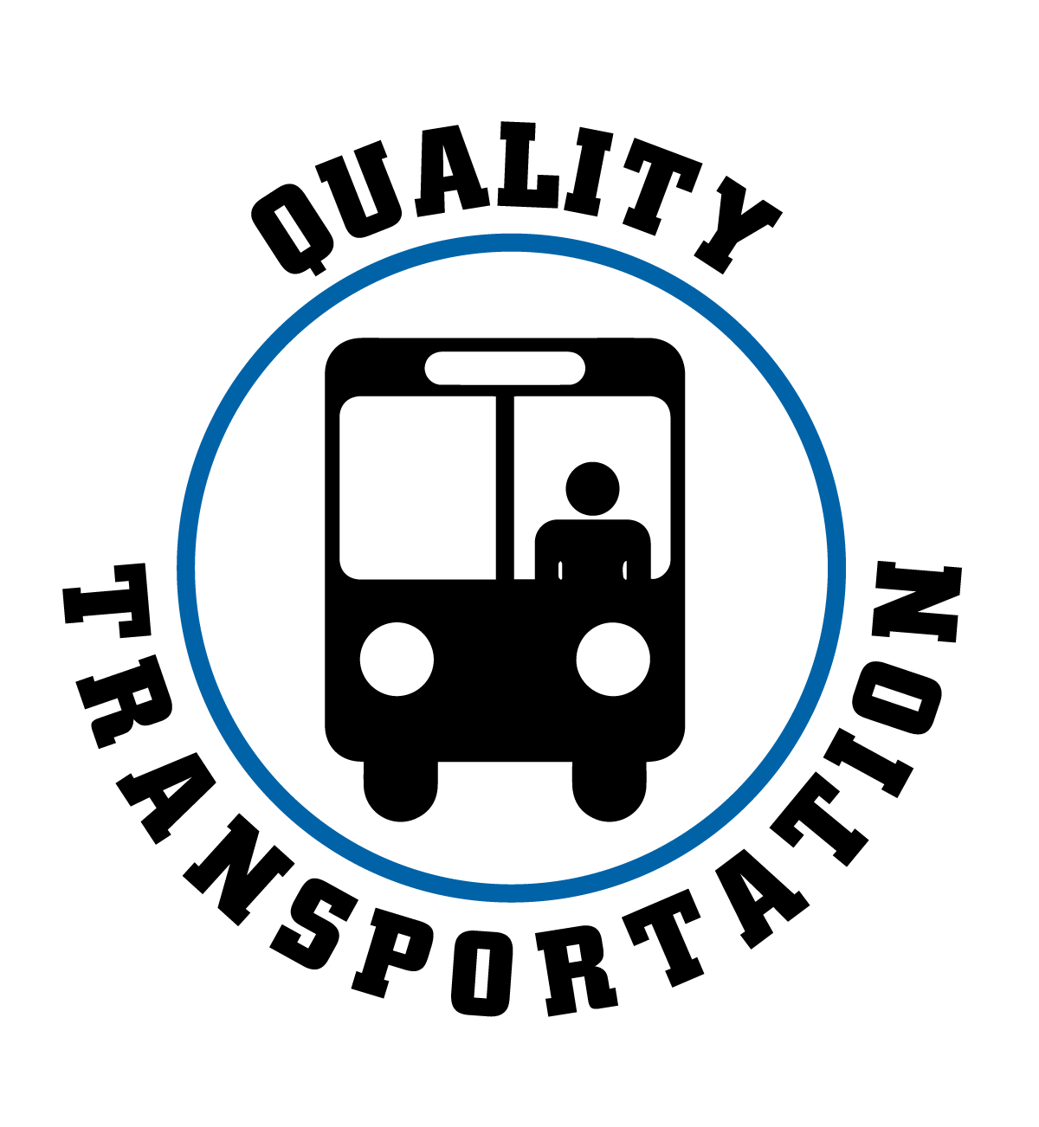
Strategic Focus Area: Quality Transportation
Strategic Objective: No
Strategic Plan Action Item: No
Key Work Item: No
Summary of Information:

The City of Winston-Salem and Winston-Salem Transit Authority (WSTA) plan to pursue competitive grant funding through the Federal Transit Administration’s (FTA) FY25 Bus and Bus Facilities Competitive Program (49 U.S.C. 5339(b)) and Low or No Emission Grant Program (49 U.S.C. 5339(c)). This program makes federal funds available to states and direct recipients to replace, rehabilitate, and purchase buses and related equipment and to construct bus-related facilities. The Low or No Emission Grant Program provides funding specifically for the purchase or lease of zero-emission and low-emission transit buses and supporting facilities.

During the FY24 cycle, the City of Winston-Salem pursued and was awarded $4,444,757 toward a total project cost of $5,232,900 for the purchase of five diesel-electric hybrid buses to replace buses reaching the end of their useful life. The 15 percent match is provided through the WSTA Reserves Fund, which is dedicated in part to provide the match for future grants for fixed route and Trans-AID bus replacements.
Committee Action:
Committee of the Whole
Committee |  | 1/21/2025 | Action | Approval
For |  | 7- yea  1- absent (Burke) | Against
Remarks:

With more fixed-route buses requiring replacement now and in the coming years, the City of Winston-Salem plans to apply for the replacement of five (5) buses. The City will provide the local match through the WSTA Reserves Fund.

The application period for FTA’s FY25 Bus and Bus Facilities Competitive Program and Low or No Emission Grant Program is anticipated to open in February 2025. The application period is forecasted to close in April 2025. This item requests Council to approve a Resolution of Support and authorize a Support Letter for the City of Winston-Salem and WSTA application for the purchase of five (5) hybrid diesel-electric buses. Upon approval, the Resolution of Support will be submitted with the application along with a Support Letter from the Mayor and Council.

